PROJECT DEVELOPMENT PHASE

1. Introduction to Development Phase
The Project Development Phase is the stage where all planning, requirement analysis, and design decisions are transformed into an actual working software product. In the Online Complaint Registration and Management System, this phase involved writing source code, integrating frontend and backend technologies, creating database schemas, and implementing user functionalities.
This phase is the core execution stage of the project where the system evolves from a concept into a fully functional application.

2. Objectives of Development Phase
The main objectives of the development phase were:
- To build a responsive and user-friendly frontend interface.
- To create a secure and scalable backend server.
- To implement authentication and role-based access.
- To design and connect MongoDB database collections.
- To integrate email notifications.
- To enable real-time complaint tracking and chat.
- To ensure modular and maintainable code structure.

3. Development Methodology
The project followed an Agile-inspired incremental development approach, meaning the system was developed module by module rather than all at once.
Iterative Development Steps
- User Registration & Login Module
- Complaint Registration Module
- Admin Dashboard & Assignment Module
- Agent Resolution Module
- Chat & Messaging Module
- Email Notification Integration
- Testing & Bug Fixing
This approach allowed continuous improvements and easier debugging.

4. Frontend Development
Technologies Used
- React.js
- Bootstrap
- Material UI
- Axios
- React Router
Key Implementations
- Responsive Sign Up & Login Forms
- Dashboard Views for Admin, Agent, and User
- Complaint Submission Forms
- Complaint Status Tracking UI
- Dropdowns and Navigation Bars
- Validation Messages and Alerts
Frontend Responsibilities
- Sending API requests using Axios
- Displaying complaint lists and statuses
- Handling form validations
- Managing user session state
The frontend ensured an intuitive and smooth user experience across different devices.

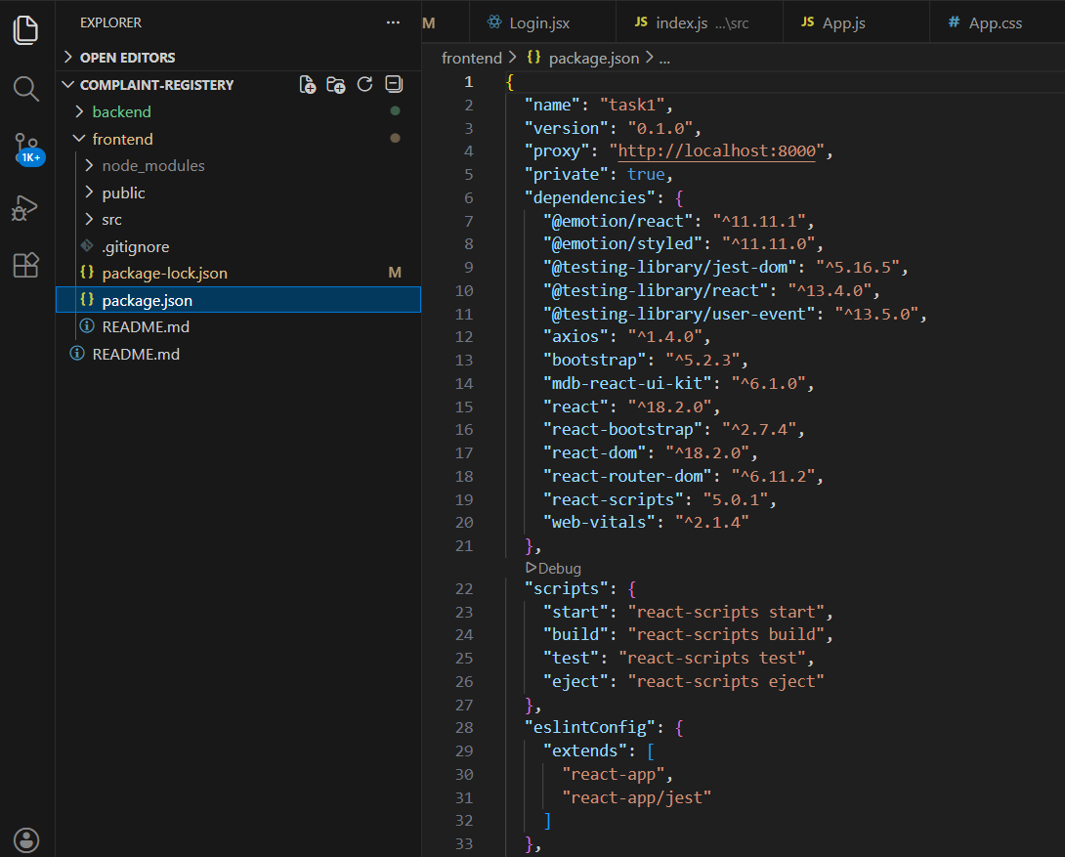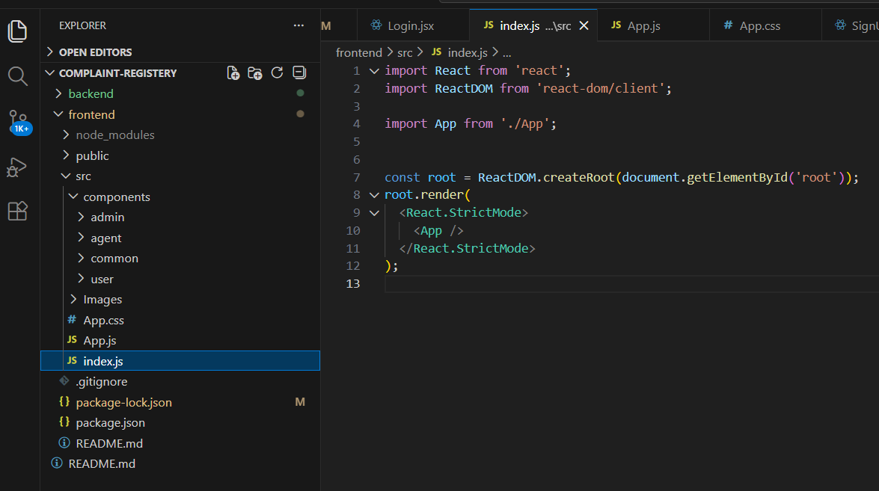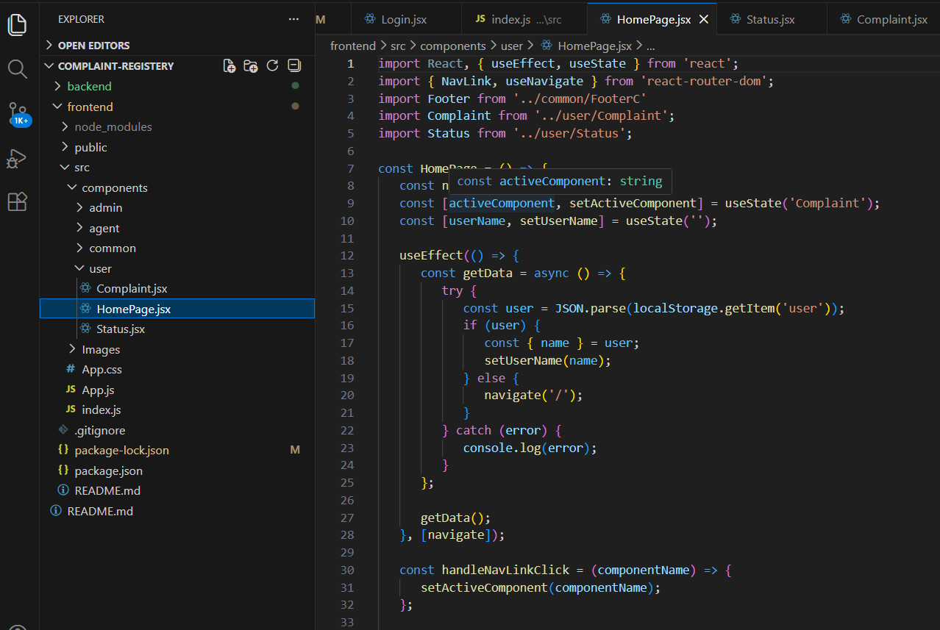

5. Backend Development
Technologies Used
- Node.js
- Express.js
- Nodemailer
- Bcrypt
- Socket.io (optional chat)
Backend Responsibilities
- Handling REST API requests
- Password encryption and verification
- Complaint data processing
- Role-based authorization
- Email notifications
- Chat message storage

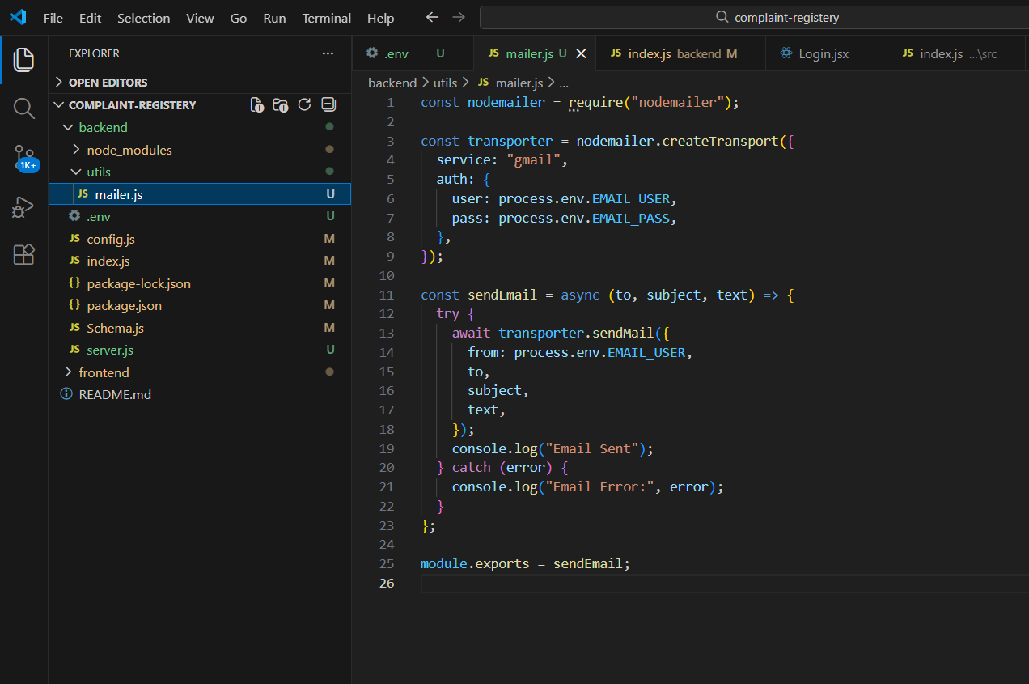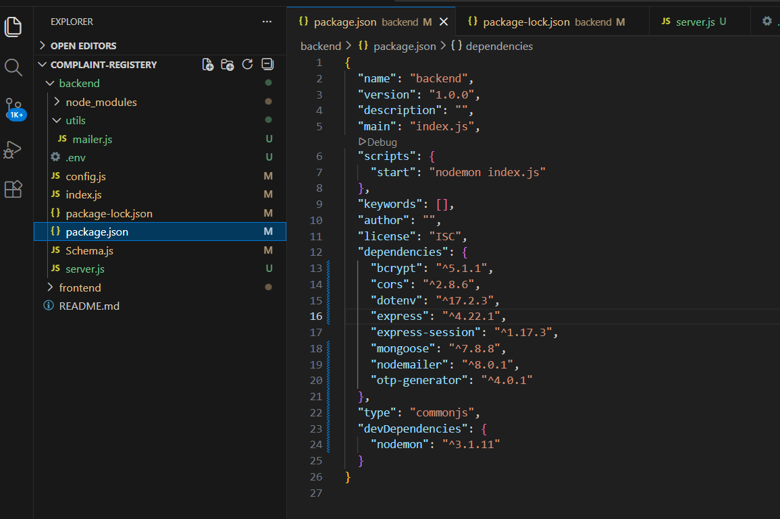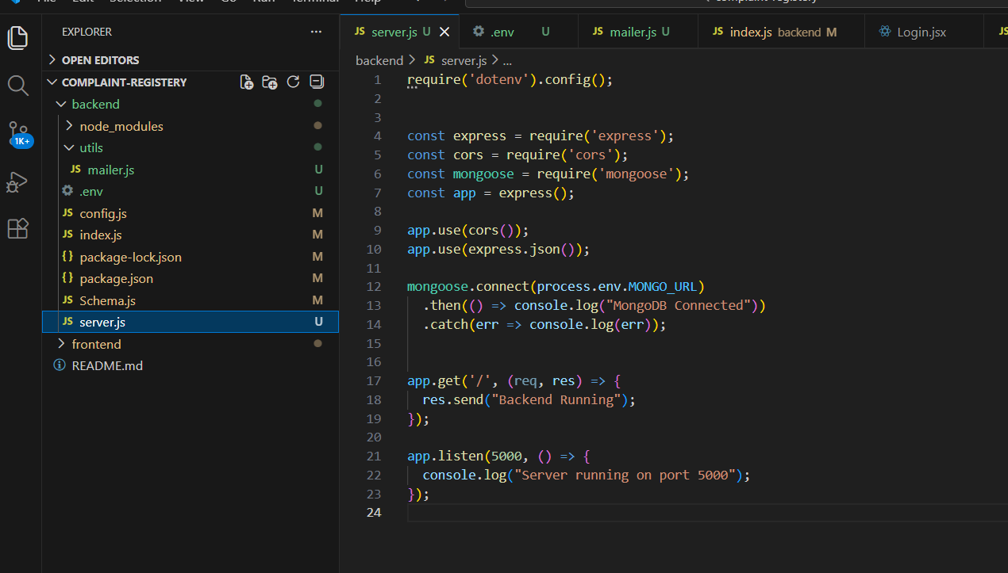

The backend served as the brain of the system, performing all logic and communication with the database.

6. Database Development
Database Used
MongoDB Atlas (Cloud Database)
Collections Created
- Users Collection – Stores user profiles and roles
- Complaints Collection – Stores complaint details and status
- Assigned Complaints Collection – Tracks agent assignments
- Messages Collection – Stores chat conversations
- OTP Collection (optional) – For email verification
MongoDB was selected for its flexibility, scalability, and ability to handle JSON-like documents efficiently.

7. Module-Wise Development
7.1 User Module
- User registration with hashed passwords
- Login authentication
- Role selection (Admin / Agent / Ordinary)
7.2 Complaint Module
- Complaint submission
- Address and product details entry
- Status updates
- Viewing complaint history
7.3 Admin Module
- View all complaints
- Assign complaints to agents
- Delete or manage users
- Monitor system activities
7.4 Agent Module
- View assigned complaints
- Communicate with users
- Update complaint status
7.5 Notification Module
- Email alerts on complaint registration
- Status update notifications
- Resolution confirmation messages

8. Integration Process
Integration involved connecting all modules so that data flows seamlessly.
Examples:
- Signup → Database Entry
- Complaint Submission → Email Notification
- Admin Assignment → Agent Dashboard Update
- Agent Resolution → User Notification
APIs were tested using Postman before frontend connection.

9. Security Measures Implemented
- Password hashing using bcrypt
- Input validation
- Role-based access restrictions
- Secure environment variables
- Email verification

10. Challenges Faced
- SMTP email authentication issues
- OTP verification errors
- Data consistency in complaint assignment
- UI responsiveness across devices
- Handling duplicate users
Each challenge was resolved through debugging, documentation review, and iterative fixes.

11. Tools & Platforms Used
- Visual Studio Code
- Git & GitHub
- MongoDB Compass
- Postman
- Chrome Developer Tools

